

Zombie Tag

EMF 2018 Initial Scoping Document.

Table of Contents

1. Executive Summary 2

# Core Concept

# Zombie Tag

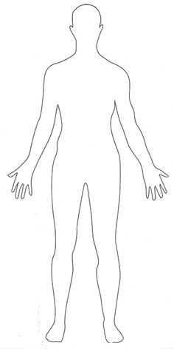 

In preparation for EMF 2018, It is planned that we take a bespoke, multi-player, engaging game along for us and a subset of the total event population to play. Exact number of players / percentage of EMF attendees can be decided upon later after costing for the equipment required to outfit the players.

The base concept is that Players are outfitted with ‘A Device’ – Vest / Tracker Band / Widget that has illuminated LEDs. These LEDs can either represent Human or Zombie. The objective of the game if you are a Human is to survive, the objective if you are a zombie is to infect humans.

As this game progresses, the number of Infected will increase, making it harder for the human team to survive. This will add to the suspense of surviving until the end game. The game is typically quite a positive one, as even after you “Lose” by being a Zombie, you still can “Win” by infecting all the remaining humans.

## Modifiers

We have a fairly good idea about the core mechanic of gameplay when underway – Its basically multiplayer Tag with two teams. However, there are lots of additional modifiers that can be added in to making it scale to a potential 100 People + event.

## Starting Stage

A possible idea for how to start this game is have everyone in an open field at EMF for the game briefing. After the briefing, we randomly ‘Seed’ the Human players with one or two infected. Whos LEDs will start blinking shortly after the end of the briefing. These are the patient zero. There should probably be a 30 second point after the flashing to ensure its not chaos after the briefing.

## Playing Stage

As gameplay progresses – It may be a good idea to have a mechanic that incentivizes the zombies to be able to “turn back” into a human – potentially after x number of successful infections. However, a downside of this may be that the best Zombies are removed from the Zombie population.

## Medpacks

It may be that “Medpacks” are left around the EMF field that supports the ability to “Heal or Restore” zombies into humans. These can be physical items that we leave around the camp/tweet about that have RFID “Resets” in them so the Humans can get them to heal their friends.

 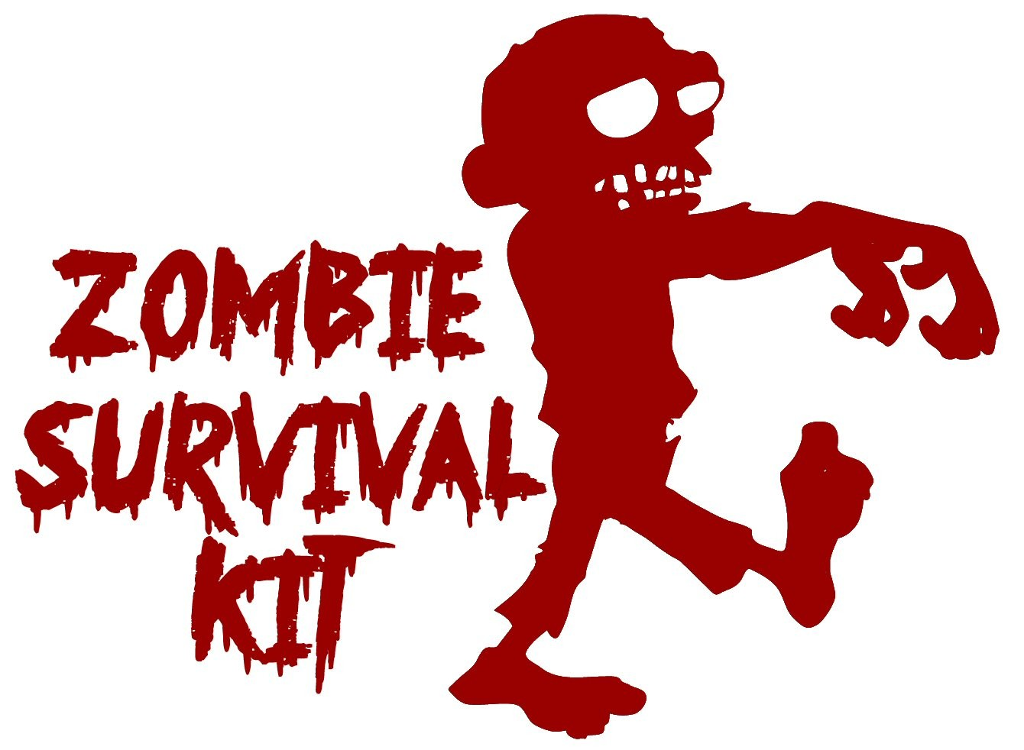

## Statistics

From the devices, it will be possible to get some really awesome metrics that we could plot on a scoreboard. This could be used to gamify the survival or infection. These are things like **Time alive as Human; Time as Zombie; A node graph of who infected who, etc.**

Gathering these statistics is something that needs solving, whether it’s automatically sent out from the devices or captured via wired download. There will be compromising likely due to cost/radio restrictions

## Endgame

It may be that at the end stages of the game, we need some way of being able to identify who “Won”, I don’t know how we would go about this just yet. But equally, I don’t think the aim of the game is to be the last one standing, just that the mechanic of play is fun.

## Rounds

As this is being held over EMF camp – with people attending Lectures and such – It may be that the devices have a way of telling the time – so that there are “Infection Windows” that occur outside of the lecture times, and maybe more in the evening.

It may be that at the end of each day – the playing field should be reset .

## Inactivity detection

# Thoughts on Hardware.

Current groupthink about the form factor of the device ranges from a Wrist mounted widget to a vest interface – Like laser quest.

The current form factor would be a size somewhere between a Fitbit and a PipBoy

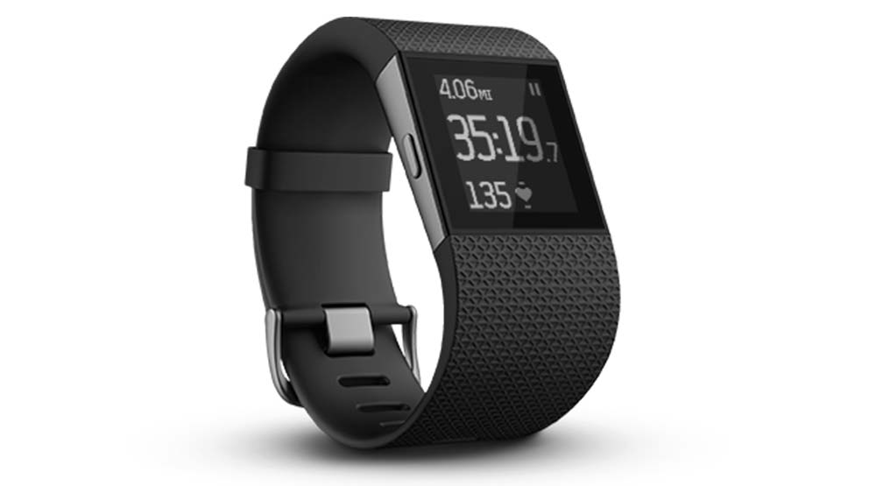 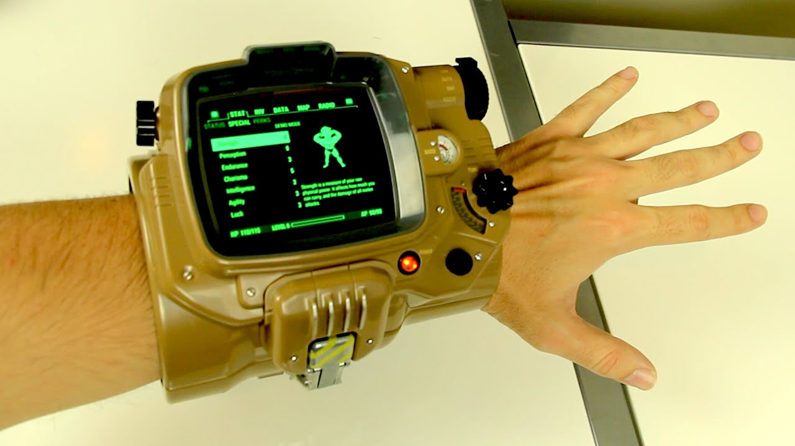

**Bill of Materials,**

So – It will need to have some LEDs to identify Human / Zombie. They need to be clearly identifyable.

It will need to support a method of “Bite” indication – IR / RFIF / NFC / BLE that is, reliable and cheap.

It may be nice to support a mesh or client server RF network for real time metrics from the game in play, but this would have to be assessed against the cost.

**Thoughts on De-Risk / Costing**

It is probably a good idea to get buy in from the EMF guys on this – One, because they are pretty cool about this sort of stuff, could provide insider knollege, people, or expertiese.

For costing, if we are able to leverage the EMF people, it may be that we can supply a “Do you want to buy in to Zombie Tag” when people purcahse tickets.

Ofcourse, we will have to test these devices thougroughly before using them at EMF, This should be allocated on the Project Plan.